**Module A.1: Simon Game Icebreaker**

**Level 0:**

**1)**

1. 6 was my personal best score.
2. 11 was my group’s personal best score.
3. Any amount of people can play the game at once and it helps to develop an individual’s concentration ability.
4. Modern computer games and this game both requires good concentration.

**2)**

1. Users input information into the game by pressing different colour buttons.
2. The game output feedback to the players by flashing lights and playing music.
3. Solo or pass it on are two different options of starting the game.
4. The only end condition for stopping the game is to lose.

**Level 1:**

**1)**

1. RalphBaer created this electronic game.
2. It was based on “Touch Me”.
3. The first game system was “The Brown Box”.
4. Ping-Pong, checkers, four different sports games, target shooting with the use of a [light gun](http://americanhistory.si.edu/collections/search/object/nmah_1302000) and a golf putting game are some games it had.

**2)**

1. Nintendo DS is the oldest game system I have ever played.
2. Most of the old games are black and white and they have a bad quality when comparing them with modern games.
3. The playing strategies are the same.

**Level 2:**

**1)**

|  |  |  |
| --- | --- | --- |
| **Object** | **Action** | **Description** |
| Red Button  Blue Button  Green Button  Yellow Button | Push/Press | Starts the game.  Record a step in the pattern.  Ends the game. |

**2)**

|  |  |  |
| --- | --- | --- |
| **Object** | **Action** | **Description** |
| Red Light  Green Light  Blue Light  Yellow Light | Flash | Indicates the start of the game, a step in the pattern and the end of the game. |
| Red Sound  Blue Sound  Yellow Sound  Green Sound | Play Tone | Indicates the start of the game, a step in the pattern and the end of the game. |

**3)**

|  |  |  |
| --- | --- | --- |
| **Input Object** | **Output Object** | **Process Connection** |
| Red Button  Blue Button  Yellow Button  Green Button | Red Light  Blue Light  Yellow Light  Green Light | Light flashes when the button is pressed. |

**Level 3:**

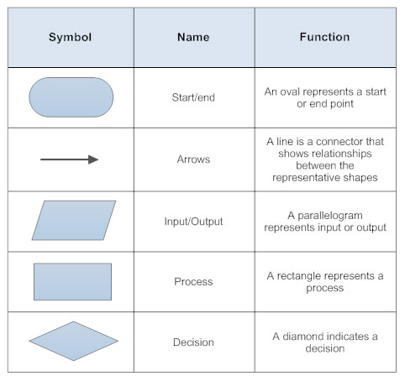

1. The flowchart consist of different shapes. In this diagram, there are two shapes(those with rounded ends) represent the start and the end points of the process and rectangles are used to show the each step throughout the process.

Input Action

Decision

Yes

Start

Output Action

Input Action

No

Step 1

Output Action

Step 2

End

Yes

Yes

**Level 4:**

Yes

Action

Decision

Press Red

Button

Decision

Press Yellow Button

Action

Action

Decision

Press Yellow Button

**1)**

Action

Action

Action

No

No

No

**2)**

Step 1

Press the red button to play solo or press the yellow button to play pass it on / multiplayer.

Step 2

Follow the pattern until you lose.

Start

Press any button to activate the game

End